WITH FSDT:

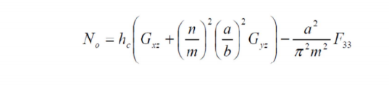

With CLT:

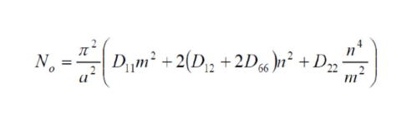

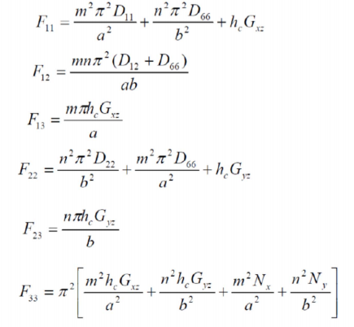

For non trivial solutions:

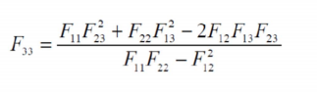

For a symmetric sandwich with homogeneous faces;

Ie:



And



Leads to:

